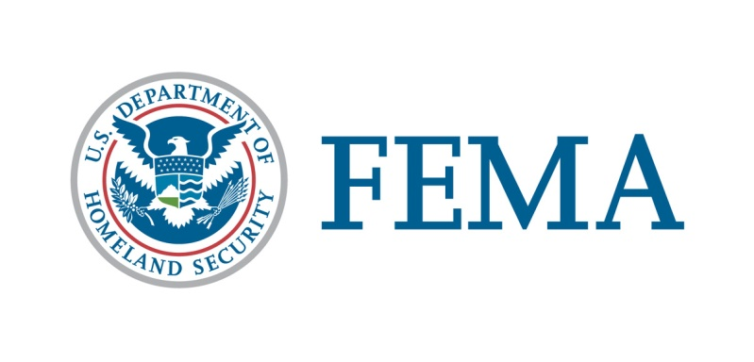

##### Congressional Affairs Division

202-646-4500

**Commonwealth of Kentucky**

**Federal Disaster Declaration Fact Sheet**

**July 22, 2025**

On May 23, 2025, President Donald J. Trump granted a Major Disaster Declaration for the Commonwealth of Kentucky triggering the release of federal funds to help people and communities recover from Severe Storms, Straight-line Winds, and Tornadoes that occurred May 16-17, 2025. **This disaster declaration has been amended as indicated below in bold.** Details of the disaster declaration and assistance programs are as follows:

Declaration Number:                                                             FEMA-4875-DR

Incident:                                                                                Severe Storms, Straight-line Winds, and Tornadoes

Incident Period:                                                                    May 16-17, 2025

Federal Coordinating Officer:                                              Jeremy Slinker

National FCO Program

Individual Assistance (IA):                                                 (Assistance to individuals and households):

IA-Designated Counties:                                                     Caldwell, Laurel, Pulaski, Russell, Trigg, and Union Counties.

**Public Assistance (PA):**                                              (Assistance for emergency work and the repair or replacement of disaster-damaged facilities):

**PA-Designated Counties:                                         Adair, Barren, Breathitt, Butler,**

**Caldwell, Carlisle, Casey, Christian, Clay, Clinton, Crittenden, Estill, Jackson, Knott, Knox, LaRue, Laurel, Lee, Livingston, Logan, Lyon, Marshall, McCreary, Menifee, Metcalfe, Owsley, Powell, Pulaski, Rockcastle, Russell, Spencer, Todd, Trigg, Union, Warren, and Wayne Counties for Public Assistance.**

Hazard Mitigation (HM):                                                          (Assistance for actions taken to

prevent or reduce long term risk to life

and property from natural hazards):

HM-Designated Areas:                                                             Under Review.

OTHER:                                                                                     Additional designations may be made

at a later date if requested by the Commonwealth and warranted by the results of further damage assessments.

Individuals in Caldwell, Laurel, Pulaski, Russell, Trigg, and Union Counties can apply with FEMA the following ways:

1. Apply online at [www.DisasterAssistance.gov](http://www.DisasterAssistance.gov).
2. Call the FEMA phone number at 1-800-621-3362.

###